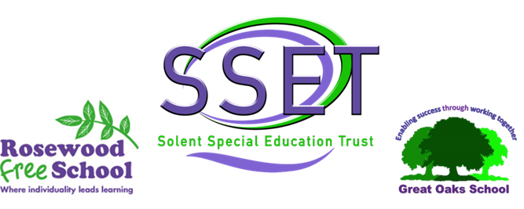

ROSEWOOD FREE SCHOOL

Title: Accessibility Plan

Lead Reviewers: Headteacher

Who this is aimed at: Whole School Community

Version | Reason for Change
V1 | New School Policy

Date Initially Implemented | October 2023

Frequency of review | Every 3 years, or if there is any change | Review due | October 2026

Policy Aims

Schools are required under the Equality Act 2010 to have an accessibility plan. The purpose of the plan is to:
- Increase the extent to which pupils with disabilities can participate in the curriculum
- Improve the physical environment of the school to enable pupils with disabilities to take better advantage of education, benefits, facilities and services provided
- Improve the availability of accessible information to pupils with disabilities
Our school aims to treat all its pupils fairly and with respect. This involves providing access and opportunities for all pupils without discrimination of any kind.
We will treat each learner with dignity and respect at all times. As an all age school we will be respectful of each learner’s age and needs as they move through the school making their individual developmental journey. We aim to provide a consistently responsive environment within which every learner’s ability to communicate is respected, responded to and developed.
The plan will be made available online on the school website, and paper copies are available upon request.
Our school is also committed to ensuring staff are trained in equality issues with reference to the Equality Act 2010, including understanding disability issues.
The school supports any available partnerships to develop and implement the plan.
Rosewood Free School is part of the Specialist Schools Trust and works in partnership with Southampton Local Authority.
Our school’s complaints procedure covers the accessibility plan. If you have any concerns relating to accessibility in school, the complaints procedure sets out the process for raising these concerns.
We have included a range of stakeholders in the development of this accessibility plan, including staff, governors, and families.

Legislation and guidance

This document meets the requirements of schedule 10 of the Equality Act 2010 and the Department for Education (DfE) guidance for schools on the Equality Act 2010.
The Equality Act 2010 defines an individual as disabled if they have a physical or mental impairment that has a ‘substantial’ and ‘long-term’ adverse effect on their ability to undertake normal day to day activities.
Under the Special Educational Needs and Disability (SEND) Code of Practice, ‘long-term’ is defined as ‘a year or more’ and ‘substantial’ is defined as ‘more than minor or trivial’. The definition includes sensory impairments, such as those affecting sight or hearing, and long-term health conditions such as asthma, diabetes, epilepsy and cancer.
Schools are required to make ‘reasonable adjustments’ for pupils with disabilities under the Equality Act 2010, to alleviate any substantial disadvantage that a pupil with disabilities faces in comparison with a pupil without disabilities. This can include, for example, the provision of an auxiliary aid or adjustments to premises.
This policy complies with our funding agreement and articles of association.

Action Plan
This action plan sets out the aims of our accessibility plan in accordance with the Equality Act 2010

To Increase Access to the Curriculum for pupils with a disability

Current Good Practice
Bespoke, personalised curriculum offer for all learners
Resources tailored to the needs of all learners
Progress tracked for all learners
Aspirational targets set effectively for all learners
Regular curriculum review ensuring that the curriculum meets the needs of all learners

Any Actions to be taken
None needed

To Improve and Maintain Access to the Physical Environment

Current Good Practice
Environment is completely accessible including:
- Wide corridors and doorways
- Disabled parking bays
- Accessible bathroom facilities
- Height adjustable furniture
- Hoists available in every learning space

Any Actions to be taken
None needed

To Improve the delivery of Information to Pupils with a Disability

Current Good Practice
Our school uses a range of communication methods to make sure that information is accessible, for example:
- Body cues
- Room cues
- Objects of Reference
- Photographs and symbols
- Signing (using Signalong)

Any Actions to be taken
None needed

Monitoring arrangements

This document will be reviewed every 3 years, but may be reviewed and updated more frequently if necessary. It will be reviewed by the Headteacher and approved by the Local Governing Body.

Related Documents
This document should be read in conjunction with other Trust and School Policies, including those relating to Equality, Disability and SEND.

