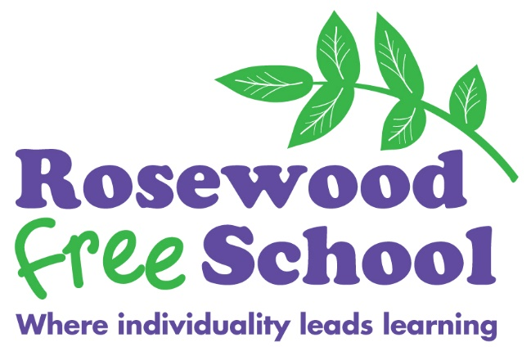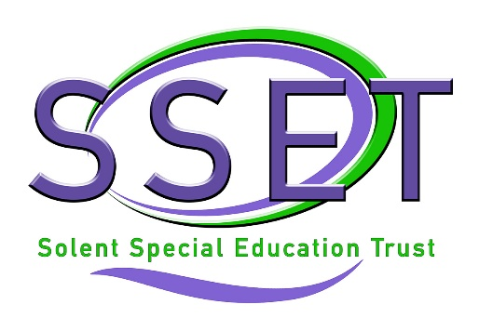

ROSEWOOD FREE SCHOOL

Title: Packed Lunch Policy

Lead Reviewer: Deputy Headteacher

Who this is aimed at: Whole School Community

Version | Reason for Change
V1 | New Policy

Date Initially Implemented

Policy Statement

This Policy applies to all families with learners attending school, and staff who are involved in supporting learners to eat and drink whether orally or otherwise.

For the purpose of this policy, the term ‘packed lunch’ refers to any food or drink, or a nutritional alternative, to be fed orally or enterally.

Application

This Policy applies to the whole school community.

Aims

- To ensure that all packed lunches brought from home and consumed in school provide learners with healthy and nutritious food, according to their individual needs.

- To ensure that high standards of health and safety are maintained during mealtimes and snack times.

Content

Rosewood Free School provides hot school meals for learners throughout the School. We cater for learners with a wide variety of dietary requirements, and also provide pureed or blended meals to consistencies needed by individuals. Our kitchen provides food of a very high quality and we highly recommend that learners have a fresh, hot school meal wherever possible.

If families choose to send packed lunches, the following applies:

- Packed lunches, including snacks, should be sent to school in a clearly named container.
- Packed lunches cannot be kept refrigerated, so families are advised to use insulated lunch bags with freezer blocks where possible.
- Packed lunches cannot be reheated by School staff, so families are advised that provision should be of a meal that can be eaten cold.
- Packed lunches should be healthy and provide the learner with a balanced diet, in line with their individual nutritional needs.
- Learners who are fed via gastrostomy should bring their prescribed feeds and drinks only.
- Blended meals for enteral feeding can be provided through the School kitchen but for health and safety reasons we cannot accept blends as a packed lunch. Families will need to complete the Blended Diet Agreement (see Appendix 1) annually, or in the case of any changes, in order to have blends provided for their child or young person.

Extra Considerations

We would ask that packed lunches are kept nut-free as there are some members of the School community who have a nut allergy.

Individual needs (eg dietary requirements not catered for) can be discussed with the Headteacher.

Staff will support children to eat and drink according to their feeding plans provided as appropriate by the relevant nursing team, speech and language therapist, and teachers. Families should approve their child or young person’s feeding plan on at least an annual basis, or in the case of any changes.

Related Documents

This document should be read in conjunction with other School Policies, including those relating to Health and Safety and Dysphagia.

Complaints

Any employee is entitled to make a complaint in respect of any breach of this Policy through the Complaints Procedure.

Appendix 1

Blended Diet Agreement

Rosewood Free School Blended Diet Agreement

I would like my son/daughter to receive a blended diet at Rosewood School.

Learner’s name |  | Date of birth
Date blended diet started |  | Volume of blend usually given
Volume of water given pre-feed |  | Volume of water given post-feed
Snacks (if needed)  Including volume |  | Additional water – time of day and volume
Any known food allergies
Any additional notes or comments | For example: additional calories, any other specific added ingredients, additional custard if desired, time taken for feed to be completed, oral tasters
Child’s dietician |  | Is blended diet approved by dietician? | Yes / No
Child’s paediatrician |  | Is paediatrician aware of blended diet feeds? | Yes / No
Signed |  | Date
Relationship to child

