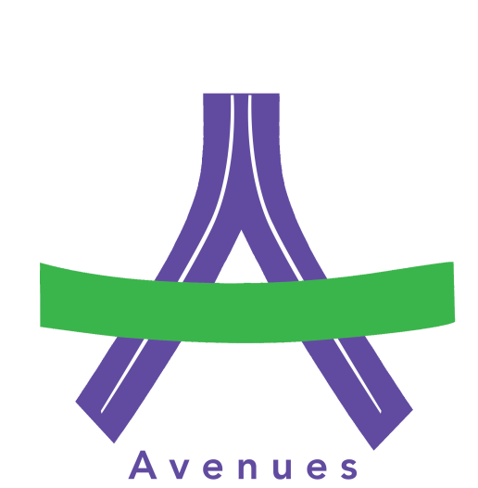

ROSEWOOD FREE SCHOOL and AVENUES

Title: Safeguarding Adults at Risk Policy

Lead Reviewer: Designated Safeguarding Lead
Who this is aimed at: All Staff

Version | Reason for Change
1 | New Policy
2 | Replaced Rosewood Free School with “Avenues Colllege”where appropriate.  Added Mental Capacity information into Summary.  Added safeguarding definition.  Added Department of Health Statement of Government Policy on Adult Safeguarding.  1.3.2 amended to reference Supervision and MyConcern.  1.5.1 and 1.5.2 amended to reflect current DSLs.  1.5.11 referenced 4 Local Safeguarding Adults Boards for Hampshire, Southampton, Portsmouth and the Isle of Wight.  Added Appendix 1: Adult Safeguarding: Viewing panels  Appendix 2: Staff suitability letter and declaration  Appendix 3: Reporting a concern via MyConcern  Appendix 4: Southampton referral form for professionals to report abuse or concerns
3 | October 2023 Review

Summary

We believe that living a life that is free from harm and abuse is a fundamental right of every person. When abuse or neglect does occur, it needs to be dealt with swiftly, effectively and in ways that are proportionate to the concerns raised. In addition, the person must be at the centre of any safeguarding response and must stay as much in control of decision making as possible. The right of the individual to be heard throughout the process is a critical element in the drive to ensure more personalised care and support. We recognise that an adult who is abused, who witnesses violence or who lives in a violent environment may feel helpless and humiliated, may blame him/herself, and find it difficult to develop and maintain a sense of self-worth. However, our students, who are at very early stages of development, are unlikely to demonstrate this as other peers may do. It is vital that all staff and volunteers can identify signs of neglect and abuse and are able to advocate for those young adults who would be unable to raise a concern themselves.

Safeguarding and protecting adults at risk effectively is central to the work of Rosewood Free School as well as Avenues (under the guidance of Rosewood Free School). It underpins the strategy to maximise the life opportunities and the health and wellbeing of disabled people. All staff and volunteers recognise that safeguarding is everyone’s responsibility irrespective of the role they undertake or whether their role has direct contact or responsibility for our users or not.

This is the latest revised version of the Safeguarding Adults Policy. The policy, procedure and guidance have been issued in accordance with the statutory safeguarding adults responsibilities, set out in the Care Act 2014 and the associated Statutory Guidance, Schedules and Regulations.

The Care Act 2014 is the most significant piece of legislation for Health and Social Care since the National Assistance Act 1948 and brings together a patchwork of Health and Social Care legislation into one statute.

The Care Act 2014 statutory guidance replaces No Secrets Guidance and sets responsibility for adult safeguarding in primary legislation, endorsing the principle of wellbeing and placing safeguarding adults’ duties on a statutory footing.
Rosewood Free School takes its safeguarding responsibilities very seriously and has a zero-tolerance approach to abuse. The Policy, Procedure and accompanying guidance applies to all adults regardless of their age, ethnicity, disability, religion, gender, gender identity or sexual orientation.

Rosewood Free School and Avenues provide services and support to young adults. In the course of our work a ‘think-family’ approach should be taken when following these policies and procedures.
This means that where there is a concern that a vulnerable adult is also at risk from abuse and/or neglect the Rosewood Free School Safeguarding Children Policy should also be followed.

Encountering situations where adults have been abused, or there is a concern about abuse can be very distressing. This policy is written to set out the school’s policy for staff, and to ensure that everyone understands the process which must be followed, at such a time, about what needs to be done.

Definitions used in policy and procedure

The links in this section refer to the new Safeguarding Adults 4LSAB multi agency policy, process and guidance issued in July 2020.

https://www.hampshiresab.org.uk/professionals-area/hampshire_4lsab_multiagency_safeguarding_adults_policy_guidance/

Safeguarding-

Safeguarding is defined as:
- Protecting young adults from maltreatment.
- Preventing impairment of young adults’ health or development.
- Ensuring that young adults are safe within the environment that they are studying/ working. All students attending work placements independently must inform college of their safe arrival at work.
- Taking action to enable all young adults have the best life chances.

Safeguarding means protecting an adult’s right to live in safety, free from abuse and neglect. It is about people and organisations working together to prevent and stop both the risks and experience of abuse or neglect, while at the same time making sure that the adult’s wellbeing is promoted including, where appropriate, having regard to their views, wishes, feelings and beliefs in deciding on any action.

Adult at Risk- Where a local authority has reasonable cause to suspect that an adult (aged 18 years or more) in its area (whether or not ordinarily resident there) —

- has needs for care and support (whether or not the authority is meeting any of those needs),
- is experiencing, or is at risk of, abuse or neglect, and
- as a result of those needs is unable to protect himself or herself against the abuse or neglect or the risk of it

The local authority must make (or cause to be made) whatever inquiries it thinks necessary to enable it to decide whether any action should be taken in the adult’s case and, if so, what and by whom.

The decision to carry out a safeguarding inquiry does not depend on the person’s eligibility for local authority services but upon the criteria stated above.

An adult at risk may therefore be a person who, for example:

- is an older person who is frail due to ill health, physical disability or cognitive impairment
- has a learning disability
- has a physical disability and/or a sensory impairment
- has mental health needs including dementia or a personality disorder
- has a long-term illness/condition
- misuses substances or alcohol
- is an unpaid carer such as a family member/friend who provides personal assistance and care to adults and is subject to abuse
- lacks mental capacity to make particular decisions and is in need of care and support

This list will not be exhaustive.
When making a decision to report a safeguarding concern to the local authority, then those considering reporting a safeguarding concern would have: a) reasonable cause to suspect that the adult may have needs for care and support (whether they are receiving care and support or not) and b) where there is reasonable cause to suspect that the adult is experiencing abuse or neglect.
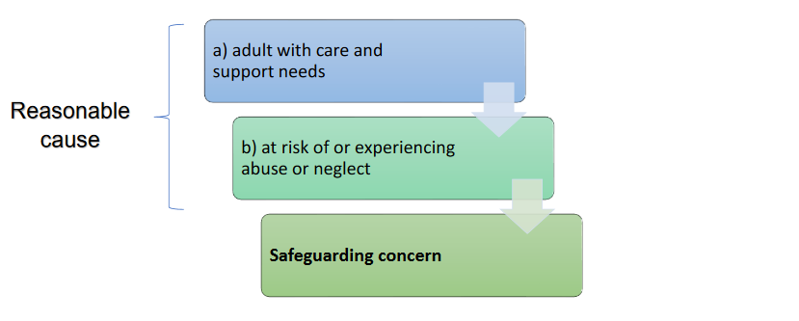
Categories of Abuse

In identifying abuse or neglect it is important to not be constrained by a definitive list of categories of abuse. The Care Act statutory guidance identifies the following categories of abuse, not as an exhaustive list but for illustrative purposes:

- Physical abuse
- Sexual abuse
- Financial and material abuse
- Psychological
- Modern slavery / human trafficking
- Neglect
- Self-Neglect
- Discriminatory abuse
- Organisational abuse

Abuse is carried out in different forms, some to be particularly aware of are;
- Domestic violence and abuse
- Honour-based violence
- Extreme radicalisation
- Hate and mate crime
- Abuse and exploitation via e-technology/social media/mobile phones

Additional factors that can increase vulnerability or risk of abuse include:
- Not having mental capacity to make decisions about own safety including fluctuating mental capacity associated with mental illness and other conditions
- Communication difficulties
- Physical dependency – depending on others for personal care and activities of daily life
- Low self esteem
- Experience of abuse
- Being cared for in a care setting, that is, more or less dependent on others
- Not getting the right amount or the right kind of care that is needed
- Isolation and social exclusion
- Lack of access to information and support
- Being the focus of anti-social behaviour

Avenues recognises that the issue of radicalisation is a growing safeguarding concern that can affect vulnerable adults as well as children and young people. The Prevent Strategy (Home Office 2011) recognises that the presence of key vulnerabilities such as Learning Disabilities, Autism or Mental Health problems can increase an individual’s susceptibility towards radicalisation and to be influenced by extremism. With any concerns that someone you come into contact with through your work is being radicalised the safeguarding procedure must be followed, and your concern raised with your Designated Safeguarding Lead.
Safeguarding Adults Policy

1. Policy

1.1. Policy Statement

1.1.1. This policy and procedure has been updated to follow the principles of the Care Act 2014 and associated statutory guidance. The purpose of this policy and procedure is to provide all staff and volunteers at Rosewood and Avenues with a framework to prevent and minimise the risk of harm to adults at risk. All staff and volunteers share this responsibility and must use the document when dealing with concern of abuse or neglect. The procedure details the steps that individuals are expected to take when presented with concerns of abuse or neglect.

1.1.2. This procedure must not be read in isolation but be read alongside the relevant local multi-agency safeguarding adults procedures. It is also essential to read and have access to Rosewood Free School’s Safeguarding Policy, this is to ensure these documents are familiar to staff in line with a ‘think family’ approach.

1.2. Principles

‘Wellbeing principle’

1.2.1. The Care Act 2014 introduces a duty to promote wellbeing when carrying out any care and support functions in respect of a person. This is a guiding principle that puts wellbeing at the heart of care and support. This principle must be applied to all safeguarding practice and decisions. “Wellbeing” is a broad concept, and it is described as relating to the following areas in particular:

- personal dignity (including treating people with respect);
- physical and mental health and emotional wellbeing;
- protection from abuse and neglect;
- control by the individual over day-to-day life (including care and support and the way it is provided);
- participation in work, education, training or recreation;
- social and economic wellbeing;
- domestic, family and personal relationships;
- suitability of living accommodation;
- the individual’s contribution to society.

1.2.2. Promoting “wellbeing” means actively seeking improvements, for the adult with care and support needs (regardless of whether they have eligible needs or not).

Six principles of adult safeguarding

1.2.3. The following six principles apply to all sectors and settings. They should inform the ways in which professionals and other staff work with adults to safeguard;

Empowerment – People being supported and encouraged to make their own decisions and informed consent. “I am asked what I want as the outcomes from the safeguarding process and these directly inform what happens.”

Prevention – It is better to take action before harm occurs. “I receive clear and simple information about what abuse is, how to recognise the signs and what I can do to seek help.”

Proportionality – The least intrusive response appropriate to the risk presented. “I am sure that the professionals will work in my interest, as I see them and they will only get involved as much as needed.”

Protection – Support and representation for those in greatest need. “I get help and support to report abuse and neglect. I get help so that I am able to take part in the safeguarding process to the extent to which I want.”

Partnership – Local solutions through services working with their communities. Communities have a part to play in preventing, detecting and reporting neglect and abuse. “I know that staff treat any personal and sensitive information in confidence, only sharing what is helpful and necessary. I am confident that professionals will work together and with me to get the best result for me.”

Accountability – Accountability and transparency in delivering safeguarding. “I understand the role of everyone involved in my life and so do they.”

Preventing abuse

1.2.4. Prevention of abuse is the primary goal. Rosewood Free School and Avenues are committed to ensuring that systems are in place which minimise the risk of abuse.

1.2.5. Prevention involves promoting awareness and understanding and supporting people to safeguard themselves from the risk of abuse. This includes helping people to identify and make informed decisions about risks and develop forward plans that keep them safe. This principle must be applied when following the procedures.

We recognise that a child who is abused, who witnesses violence or who lives in a violent environment may feel helpless and humiliated, may blame him/herself, and find it difficult to develop and maintain a sense of self-worth. However, our pupils, who are at very early stages of development, are unlikely to demonstrate this as other peers may do.
.
All staff and volunteers are vigilant to changes in the presentation of our young people and would identify an early indicator of any form of abuse through our recordings system, both for learning and emotional wellbeing.

Concerns are raised supportively with families and tracked on our online reporting system, My Concern.

We recognise that the school and/or service may provide the only stability in the lives of young people who have been abused or who are at risk of harm.

We recognise that Rosewood Free School and Avenues play a significant part in the prevention of harm to our students through an ethos of protection that is established by the staff, who know the learners really well and can identify any changes in the responses they make.

We accept that research shows that the behaviour of a young person in these circumstances may range from that which is perceived to be normal to aggressive or withdrawn, however we must be alert to any changes in the behaviour of our students.

We will support all pupils by:

- Maintaining an ethos that is understood by all staff, which enables young people to feel secure.
- Encouraging the development of self-esteem and resilience in every aspect of life including through the curriculum.
- Promoting a caring, safe and positive environment within the colleges.
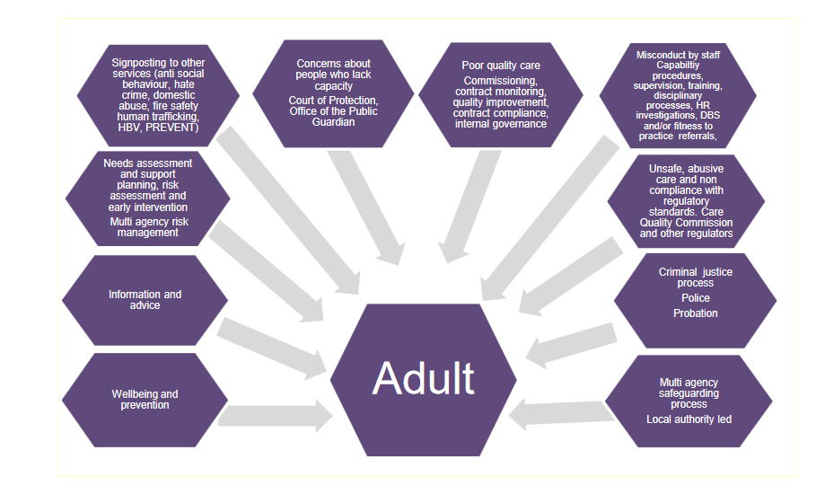
- Liaising and working together with all other support services and those agencies involved in the safeguarding of adults at risk.

Making safeguarding personal

1.2.6. We are committed to the principles of ‘Making Safeguarding Personal’, the aim of which is to ensure that safeguarding is person-led and focused on the outcomes that people want to achieve. It engages the person in a conversation about how best to respond to their safeguarding situation in a way that enhances involvement, choice and control as well as improving quality of life, wellbeing, and safety. It is about seeing people as experts in their own lives and working alongside them. It is a shift from a process supported by conversations to a series of conversations supported by a process.

Mental capacity and consent

1.2.7. The law presumes that adults have mental capacity to make their own decisions. However, there will be times and situations in which an individual lacks mental capacity in relation to decisions. Issues of mental capacity and the ability to give informed consent are central to decisions and actions within the safeguarding adults procedure. All interventions need to consider the ability of adults to make informed choices about the way they want to live and the risks they want to take. If an individual refuses intervention to support them with a safeguarding concern or requests that information about them is not shared, their wishes should be respected. However, there are some circumstances where this consent can be overridden.

Information sharing

1.2.8. Early sharing of information is key to providing effective support where there are emerging concerns. The wellbeing of adults at risk of abuse is likely to be more important than concerns about sharing information.

1.2.9. No-one should assume that someone else will pass on information which they think may be critical to the safety and wellbeing of an adult at risk of abuse or neglect. If anyone has concerns about an adult’s welfare and believes they are suffering abuse or neglect, they should immediately share their concerns with their line manager. Everyone has a duty to act.

1.2.10. We are committed to working with its safeguarding partners, cooperating and sharing information when there are safeguarding enquiries with our adults and when we know other adults and/or children could also be at risk.

1.3. Who is covered by this policy and procedure?

1.3.1. The application of this policy is mandatory for all staff, volunteers, agency/bank staff and all other Rosewood and Avenues representatives.

1.3.2. Staff understanding of this policy will be assured through training, assessment of competency and supervision. Supervision is an important part of safeguarding, as it ensures staff follow preventative measures such as logging safeguarding concerns through MyConcern safeguarding web platform as well as raising concerns directly to the DSL. Supervision allows the DSL to monitor staff regarding how safeguarding concerns are raised and followed up, as well as providing opportunities to improve safeguarding through training and weekly team meetings where updates to safeguarding matters can be addressed.

1.3.3. This policy is available on our website, referred to in the statement of purpose for various services, introduced during staff induction, and training is provided.

1.4. Areas of Governance

1.4.1. This is a mandatory policy for all Rosewood and Avenues staff to adhere to and is approved by the Governing Body.

1.4.2. The Governing Body looks to the support & professionalism of staff and volunteers at all levels in making this policy truly effective. This policy will be monitored by the Head teacher and the Designated Safeguard Lead.

1.4.3. This policy will be reviewed and updated annually from implementation by the Designated Safeguard Lead unless legal changes demand a more timely amendment.
1.4.4. We adhere to strict guidelines on recruitment of staff and volunteers as part of its duty to safeguard adults and children. All staff are eligible for a Disclosure and Barring check need to have a cleared check prior to starting in their role, plus clearance through the staff suitability declaration.

1.5. Following Local Authority Policy and Procedures
The Governing Body of our school is responsible for ensuring the annual review of this policy.

1.5.1 Rosewood Free School has a Designated Person for Child Protection known as the designated safeguarding lead (DSL). Currently that person is Sarah Clarke. She has undertaken appropriate training for the role.

1.5.2 We have deputy DSLs: Zoe Evans and Kata Lajko

1.5.3 All adults, (including supply teachers, contractors, visitors and volunteers) new to Rosewood and Avenues will be made aware of the policy and procedures for safeguarding adults at risk, the name and contact details of the designated safeguarding lead and have these explained, as part of their induction.

1.5.4 All members of staff are provided with opportunities every year to receive training via e-learning on the Every platform, or delivered by the Designated safeguarding lead in order to develop their understanding of the signs and indicators of abuse, how to respond to a pupil who discloses abuse and the procedure to be followed in appropriately sharing a concern of possible abuse or a disclosure of abuse.

1.5.5 All members of staff also complete Prevent training to support the development of their understanding of radicalisation and extremism.

1.5.6 All parents/carers are made aware of safeguarding through policies published on the school website.

    - Our selection and recruitment policy includes all checks on staff and regular volunteers’ suitability including Disclosure and barring services (DBS) checks as recommended by the LA and in accordance with current legislation. This will help ensure that:
      - Employers benefit from an improved vetting service for those who work, or wish to work, with children and/or vulnerable adults, and that
      - Those who are known to be unsuitable are barred from working with children and/or vulnerable adults at the earliest possible opportunity.
The Scheme provides significant safeguards but does not remove the need for employers to have robust recruitment procedures.

1.5.8 Our procedures will be regularly reviewed and up-dated with staff and governors.

1.5.10 The name of the designated safeguarding lead will be clearly shown on site, with a statement explaining the role in referring and monitoring cases of suspected abuse. In addition, posters and photographs are displayed in reception and in all classrooms and work rooms with the contact details of internal and external individuals and agencies to report to.

1.5.11 This policy is based on the principles of the Guidance of the 4LSAB, the 4 Local Safeguarding Adults Boards for Hampshire, Southampton, Portsmouth and the Isle of Wight who produce one set of guidance.

This policy and procedures must be read in conjunction with the following policies:
Whistle blowing, Code of conduct, Touch, Behaviour, Bullying, Social media, Physical intervention, Pupil Charter, Medicines administration, Child missing education, Single equalities, Health and safety, Advanced care planning

Links to relevant law and guidance:
Care Act 2014 Statutory Guidance (Department of Health, 2014) https://www.gov.uk/government/publications/care-act-statutory-guidance/care-and-support-statutory-guidance
Mental Capacity Act 2005 Code of Practice (Department of Constitutional Affairs, 2007) https://www.gov.uk/government/publications/mental-capacity-act-code-of-practice
Government Statement of Policy on Adult Safeguarding (HM Government, 2013) https://www.gov.uk/government/uploads/system/uploads/attachment_data/file/197402/Statement_of_Gov_Policy.pdf
Inter-Authority Safeguarding Arrangements (ADASS June 2016) https://www.adass.org.uk/media/5414/adass-guidance-inter-authority-safeguarding-arrangements-june-2016.pdf
Making safeguarding personal: a toolkit for responses https://www.local.gov.uk/making-safeguarding-personal-toolkit-responses
Adult safeguarding and domestic abuse https://www.local.gov.uk/sites/default/files/documents/adult-safeguarding-and-do-cfe.pdf
Safeguarding adults at risk of harm: A legal guide for practitioners https://www.scie.org.uk/publications/reports/report50.asp

Other relevant links:
Southampton Local Safeguarding Adults Board
https://southamptonlsab.org.uk/

Hampshire Adults’ Health and Care support and referral
https://www.hants.gov.uk/socialcareandhealth/adultsocialcare/contact/start-a-referral

